

Project Communication Plan and Risk Register

Ankita Gangotra

Document Control

|  |  |  |  |  |
| --- | --- | --- | --- | --- |
| Version Number | Modified By | Date | Section(s) Modified | Comments |
| 0.1 | A.Gangotra | 28.02.2014 | Created | *Created Risk Register.* |
| 0.2 | A.Gangotra | 25.04.2014 | Project Communication Plan | *Created Project Communication Plan.* |
| 0.3 | A.Gangotra | 09.06.2014 | Change Management of Project | *Created Changes Management of Project.* |
| 1.0 | A.Gangotra | 09.06.2014 | - | *Made minor changes to final document.* |

# Project Communication Plan

## 1.1 Project communication documents

This section includes a project communication table to identify the communication documents needed for the project, the recipients of the documents, persons responsible for creating and updating the documents, and how often the document need to be updated for the smooth functioning of the project.

### 1.1.1 Project communication table

|  |  |  |  |
| --- | --- | --- | --- |
| Document | Responsibilities | Recipients | Update Frequency |
| Team Meeting Agendas | Project Manager | Project Team | Before every meeting |
| Sub-team Meeting Agendas | Project Manager, Software Manager & Finance Manager | Management Team, Software Team & Finance Team | Before every sub-team meeting |
| Weekly Reports & QA Metrics | Project Team | Project Team | Every week |
| Timesheets | Project Team | Finance Manager & Project manager | Every week |
| Project Plan & Schedule | Project Manager & Software Manager | Project Team | As and when required |

## 1.2 Team structure

The following diagram illustrates the structure and communication relationships of the project team. For more details, please refer to the QA Manual.

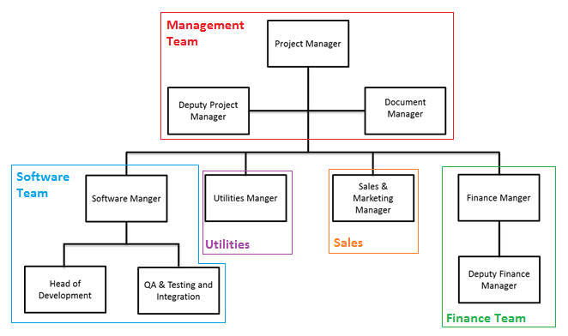

Figure : Organizational Structure of Spoon

# 2. Risks Register

The following table lists all the potential problems that might arise during the project, theirs causes, symptoms, consequences and possible solutions.

|  |  |  |  |  |
| --- | --- | --- | --- | --- |
| **Risk** | **Probability** | **Impact** | **P X I** | **Resolution** |
| Failure to meet a project requirement. | 4 | 5 | 20 | **Control**: Have regular review meetings where requirement conformity is checked. Make sure that the design and the development of the product is organised in a way that simplifies rollback and re-implements the missing requirements with as little modification to other parts as possible. |
| Employees producing work that is below the expected standard. | 4 | 4 | 16 | **Avoidance**: Have a system to review work done by each member.  **Control**: Hold separate meetings with the members in question. Transference: If even after repeated counselling there is no change, talk to the board members (the supervisor and/or second supervisor) to take further action. |
| QA Metrics not being measured regularly | 4 | 4 | 16 | **Control**: Have a weekly review system for employees |
| Deadline overdue on deliverables. | 3 | 5 | 15 | **Avoidance**: Have a good and appropriate project plan Control: Have regular project plan review meetings in which possible overruns can be identified and rescheduling can be considered if necessary. |
| Deliverable not up to company standards | 3 | 5 | 15 | **Avoidance:** Have a QA system in check. **Control:** Have a standards review meeting to amend the oversights in the deliverable. |
| Failure in talks for contract agreement | 3 | 5 | 15 | **Control:** Try and negotiate term and conditions to further the transactions. Transference: Talk to other groups. |
| Conflict within the contract | 3 | 5 | 15 | **Avoidance:** Have a clear and transparent contract agreement. **Control:** Reach a peaceful agreement with other group to resolve conflict. **Transference:** Get in touch with project coordinator if all else fails. |
| Modules sold unacceptable to buyer | 3 | 5 | 15 | **Avoidance:** Keep an open dialogue with the other group to understand requirements. **Control:** Have a meeting with other group to identify and modify unacceptable elements. |
| Some group members don’t get along with each other. | 3 | 4 | 12 | **Control**: Try to resolve any issues that group members might have. Acceptance: Consider assigning and delegating tasks to minimise disruption within the group as a whole. |
| Finding out late during the project that one member has a lot more work to do than the others. | 3 | 4 | 12 | **Avoidance**: Review the workload for each member regularly to make sure there is parity in the amount of work done by each person. |
| Negative attitude/ lack of confidence in employees | 3 | 4 | 12 | **Avoidance**: Maintain a positive working environment. **Control**: Have separate meetings to reassure and boost morale of employees. |
| Documentation not being produced on time | 3 | 4 | 12 | **Avoidance**: Have an early warning system. **Control**: Follow up on employees not producing documents and hold meetings with them if necessary. |
| Disagreement with other groups on joint assignments | 3 | 4 | 12 | **Control**: Hold meetings with other groups to find a resolve. |
| The prolonged absence of a team member. | 2 | 4 | 8 | **Control**: Have more than one team member trained to do any task. Acceptance: Adjust schedules as appropriate. |
| Conflicts within pre-determined PWS | 2 | 4 | 8 | **Control**: Have an intergroup meeting to overcome these conflicts |
| Modules bought not up to company standards and coding practices | 2 | 4 | 8 | **Avoidance**: Keep an open dialogue with the other group to make sure they understand the requirements. |
| PWS not being adhered to | 2 | 3 | 6 | **Control**: Hold a meeting to identify and correct breaches of the PWS |

# 3. Change Management Process

Any changes in the QA manual or the project scope are brought in by the following steps:

1. Discussion and ratification of the change by the project team member in a team meeting,
2. Changes then sanctioned by the management team.
3. Changes finally made by the Documentations Manager/Software Manager/Head Of